PSEUDOCODE

- Resubmit pseudocode from previous pseudocode assignments and update as necessary:
Vector
- Open the file, read the data, parse each line, and check for formatting errors:
function loadFile(filename):
open file with name filename
for each line in file:
if line is not properly formatted:
print “Formatting Error”
continue
parse line into course data
create course object with parsed data
add course object to vector
close file
- Create course objects:
function createCourseObject(courseData):
course = new Course()
course.id = courseData.id
course.title = courseData.title
course.prerequisites = courseData.prerequisites
return course
- Print course information and prerequisites:
function printCourseInfo(course):
print “Course ID: “ + course.id
print “Course Title: “ + course.title
print “Prerequisites: “ + course.prerequisites

Hash Table
- Open the file, read the data, parse each line, and check for formatting errors:
function loadFile(filename):
open file with name filename
for each line in file:
if line is not properly formatted:
print “Formatting Error:
continue
parse line into course data
create course object with parsed data
add course object to hash table
close file
- Create course objects:
function createCouseObject(courseData):
course = new Course()
course.id = courseData.id
course.title = courseData.title
course.prerequisites = courseData.prerequisites
return course
- Print course information and prerequisites:
function printCourseInfo(course):
print “Course ID: “ + course.id
print “Course Title: “ + course.title
print “Course Prerequisites: “ + course.prerequisites

Binary Search Tree
- Open the file, read the data, parse each line, and check for formatting errors:
function loadFile(filename):
open file with name filename
for each line in file:
if line not properly formatted:
print “Formatting Error”
continue
parse line into course data
create course object with parsed data
add course object to binary search tree
close file
- Create course objects:
function createCourseObject(courseData):
course = new Course()
course.id = courseData.id
course.title = courseData.title
course.prerequisites = courseData.prerequisites
return course
- Print course information and prerequisites:
function printCourseInfo(course):
print “Course ID: “ + course.id
print “Course Title” + course.title
print “Course Prerequisites: “ + course.prerequisites

- Create pseudocode for a menu:
function menu():
while true:
print “1. Load file data”
print “2. Print all courses”
print “3. Print course information”
print “9. Exit”
choice = get user input
if choice == 1:
loadFile(“courses.txt”)
else if choice == 2:
printAllCourses()
else if choice == 3:
courseId = get user input
course = findCourse(courseId)
if course is not null:
printCourseInfo(course)
else:
print “Course not found”
else if choice == 9:
break

- Design pseudocode that will print out the list of the courses in the Computer Science program in alphanumeric order:
function printAllCourses():
inOrderTraversal()
for each course in traversal result:
printCourseInfo(course)
EVALUATION
- Evaluate the run time and memory of data structures that could be used to address the requirements:
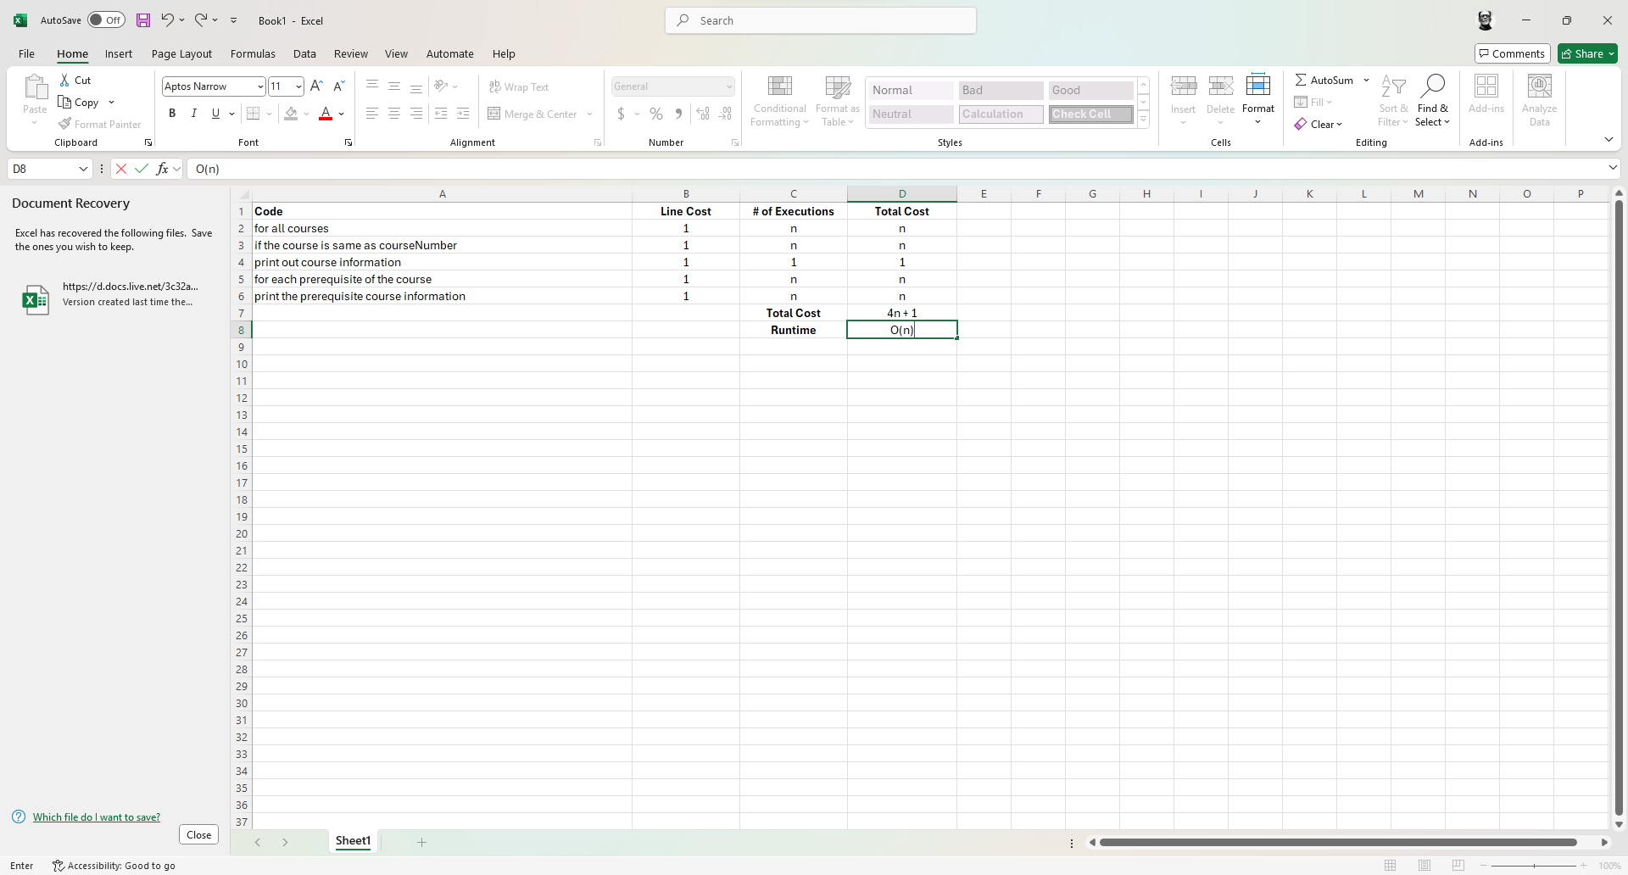

- Explain the advantages and disadvantages of each data structure in your evaluation:
- Vector
Advantages – easy to implement and efficient for small sets of data
Disadvantages – inefficient for large sets of data due to O(nlog n) sorting time
- Hash Table
Advantages – fast insertion and search, O(1) average time complexity
Disadvantages – O(nlog n) sorting time
- Binary Search Tree
Advantages – efficient for sorted data, O(nlog n) insertion and O(n) traversal
Disadvantages – more complicated than other data structures to implement

- Make a recommendation for which data structure you plan to use in your code:
Based on the results of the analysis and the requirements, I recommend using the Hash Table. The hash table provides the best performance for insertion, search, and delete functions, which is essential for handling the data in large data structures efficiently. Though it may require sorting for printing data, the overall advantages outweigh its disadvantages.

